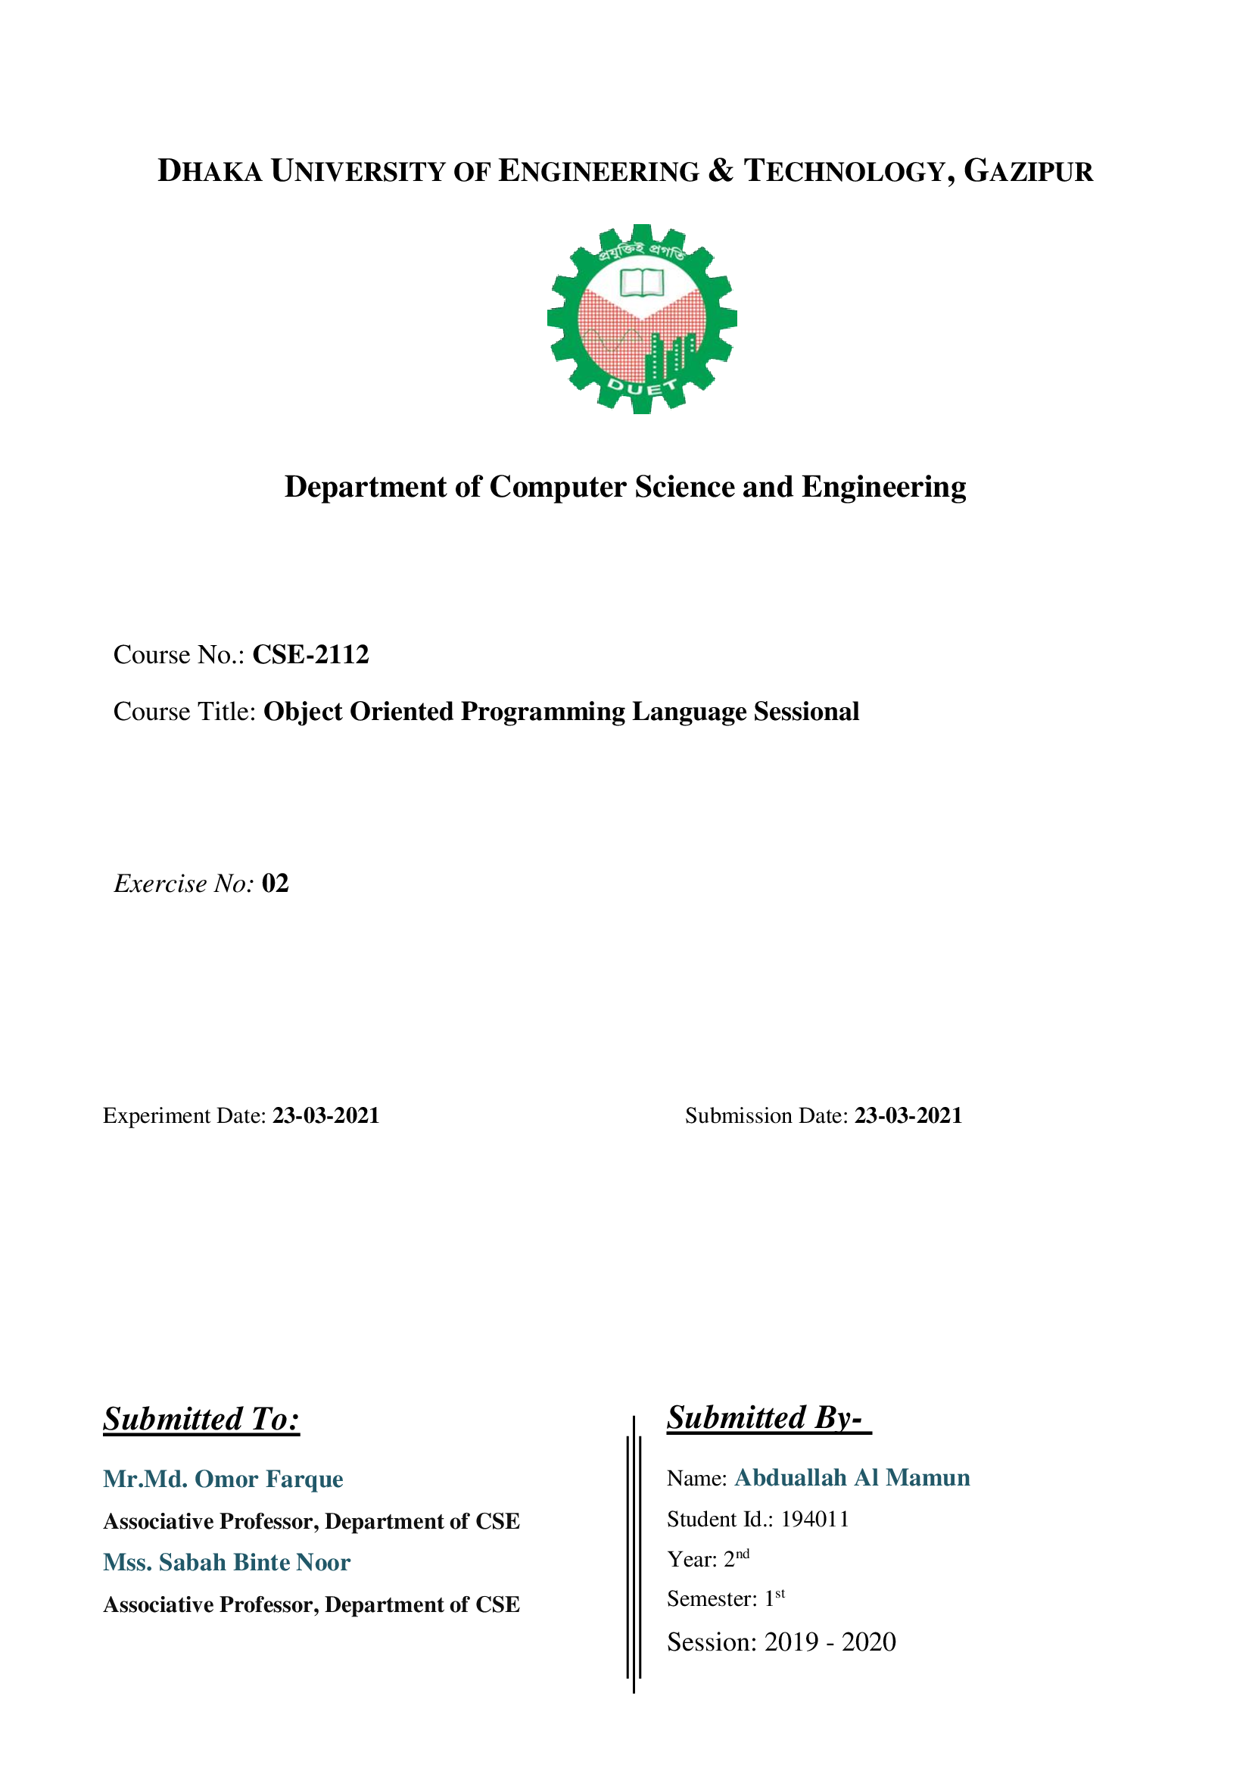

**Problems No:** 03

**Problems Title:** Write a C++ program (using function overloaded) to sort 4 integer values, or 4 long values, or 4 double values or 4 character values.

**Solution:**

|  |
| --- |
| #include<iostream>  #include <list>  using namespace std;  void userDefinedFunction(int,int,int,int );  void userDefinedFunction(long,long,long,long );  void userDefinedFunction(double,double,double,double );  void userDefinedFunction(char,char,char,char );  int main()  {  cout<<"******Sort For Integer Value*********\n";  userDefinedFunction(87,343,8,-10);  cout<<"\n\n******Sort For Long Value**********\n";  userDefinedFunction(66554433,11223344,88776655,33445566);  cout<<"\n\n******Sort For Double Value********\n";  userDefinedFunction(20.09,12.76,-0.32,01.00);  cout<<"\n\n******Sort For Characters***********\n";  userDefinedFunction('T','D','U','E');  return 0;  }  void userDefinedFunction(int a,int b,int c,int d)  {  list<int> mylist{ a, b, c, d };  cout<<"Before Sorted For Integer"<<endl;  for (auto it = mylist.begin(); it != mylist.end(); ++it)  cout << ' ' << *it;  cout<<"\nAfter Sorted For Integer"<<endl;  mylist.sort();  for (auto it = mylist.begin(); it != mylist.end(); ++it)  cout << ' ' << *it;  }  void userDefinedFunction(long a,long b,long c,long d)  {  list<long> mylist{ a, b, c, d };  cout<<"Before Sorted For Long"<<endl;  for (auto it = mylist.begin(); it != mylist.end(); ++it)  cout << ' ' << *it;  cout<<"\nAfter Sorted For Long"<<endl;  mylist.sort();  for (auto it = mylist.begin(); it != mylist.end(); ++it)  cout << ' ' << *it;  }  void userDefinedFunction(double a,double b,double c,double d)  {  list<double> mylist{ a, b, c, d };  cout<<"Before Sorted For double"<<endl;  for (auto it = mylist.begin(); it != mylist.end(); ++it)  cout << ' ' << *it;  cout<<"\nAfter Sorted For double"<<endl;  mylist.sort();  for (auto it = mylist.begin(); it != mylist.end(); ++it)  cout << ' ' << *it;  }  void userDefinedFunction(char a,char b,char c,char d)  {  list<char> mylist{ a, b, c, d };  cout<<"Before Sorted For char"<<endl;  for (auto it = mylist.begin(); it != mylist.end(); ++it)  cout << ' ' << *it;  cout<<"\nAfter Sorted For char"<<endl;  mylist.sort();  for (auto it = mylist.begin(); it != mylist.end(); ++it)  cout << ' ' << *it;  } |

**Output:**

